Area of the Path

Here we will discuss about area of the path. It is observed that in square or rectangular gardens, parks, etc., some space in the form of path is left inside or outside or in between as cross paths. We will apply this concept for the areas of rectangle and square to determine the areas of different paths.
Worked-out examples on Area of the Path:
1. A rectangular lawn of length 50 m and breadth 35 m is to be surrounded externally by a path which is 2 m wide. Find the cost of turfing the path at the rate of $3 per m².
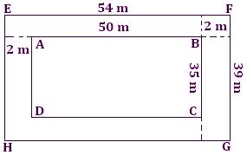
Solution:
Length of the lawn = 50 m
Breadth of the lawn = 35 m
Area of the lawn = (50 × 35) m²
= 1750 m²
Length of lawn including the path = [50 + (2 + 2)] m = 54 cm
Breadth of the lawn including the path = [35 + (2 + 2)] m = 39 m
Area of the lawn including the path = 54 × 39 m² = 2106 m²
Therefore, area of the path = (2106 - 1750) m² = 356 m²
For 1 m², the cost of turfing the path = $ 3
For 356 m², the cost of turfing the path = $3 × 356 = $1068

2. A square flowerbed is surrounded by a path 10 cm wide around it. If the area of the path is 2000 cm², find the area of the square flower-bed.
Solution:
In the adjoining figure,
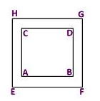
ABCD is the square flowerbed.
EFGH is the outer boundary of the path.
Let each side of the flowerbed = x cm
Then, the area of the square flowerbed ABCD (x × x) cm² = x² cm²
Now, the side of the square EFGH = (x + 10 + 10) cm = (x + 20) cm
So, the area of square EFGH = (x + 20) (x + 20) cm² = (x + 20)² cm²
Therefore, area of the path = Area of EFGH - Area of ABCD
= [(x + 20)² - x²] cm²
= [x² + 400 + 40x - x²] cm² = (40x + 400) cm²
But the area of path given = 2000 cm²
Therefore, 40x + 400 = 2000
⟹ 40x = 2000 - 400
⟹ 40x = 1600
⟹ x = 1600/40 = 40
Therefore, side of square flowerbed =40 cm
Therefore, the area of the square flowerbed = 40 × 40 cm² = 1600 cm²

